Ean Masoner Module 5.2 Assignment

1st experiment Current Timestamp

This function is used to put the timestamp on. This can be used for documents or store time values without any time zone. This data is also automatically updated.

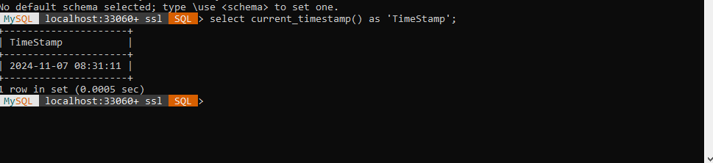

2nd experiment Current User

This function tells you who is currently using the server, and the root connection. This is helpful because it allows you to know who is using the database. This would be used to see current database connections.

3rd experiment Divide function

I used this function in the scenario to take two numbers and divide them to set an hourly wage for my employee. This function would be used to reduce two large numbers or used like I did for wage calculation.

